St Augustine’s Catholic Primary & Nursery School, a Voluntary Academy

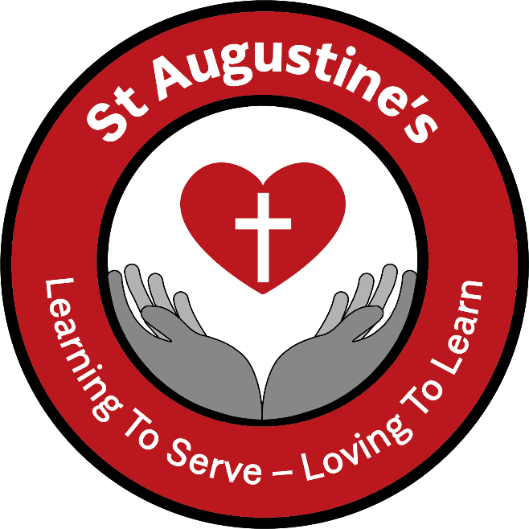

School Uniform Policy

Headteacher: | Frances Moore
Date Adopted: | July 2022
Review Date: | July 2023

Principles
St Augustine’s Catholic Primary Academy’s, it is the school’s policy is that all children should wear clothing that is comfortable and encourages a positive learning climate and reflects our mission statement. All children should wear school uniform when attending school, or when participating in an event organised by school outside normal school hours.

Aims
Our policy is based on the belief that a school uniform:
• promotes a sense of pride in the school
• a feeling of belonging
• is practical and smart
• identifies the children with the school
• is not distracting in class (as fashion clothing might be)
• makes children feel equal to one another in terms of appearance
• reflects the sense both of community and of diversity that the school takes pride in
• is regarded as suitable and good value for money

All pupils attending St Augustine’s Catholic Primary School are required to wear the school uniform as listed below:

Boys | Girls
White polo shirt  Red V neck jumper  Grey trousers  Grey shorts (Summer)  Grey Socks | Grey pinafore dress/grey skirt/grey trousers  White polo shirt  Scarlet Red tights  Scarlet Red cardigan  Red & white gingham dress (Summer)  White socks

Summer Gingham dresses for girls and shorts for boys can be worn from after the Easter holiday until October half term. Winter uniform should be worn the rest of the time.

P.E
All children require a red or white T-shirt and shorts and a pair of soft shoes for P.E. These should be kept in school in a drawstring bag.

Red jumper and white t-shirts, with school logo are available through Just Schoolwear. You can order online at:

https://just-schoolwear.co.uk/product-category/st-augustines-catholic-primary-school/

PLEASE ENSURE ALL CLOTHING IS CLEARLY MARKED WITH YOUR CHILDS NAME

Footwear
Sensible and appropriate black leather footwear should be worn at all times. Trainers are only permissible during outdoor activities. Fashion shoes, raised heels, open toed sandals, designer label footwear, prominent logos and boots above ankle height are all examples of inappropriate footwear which are not permitted.

Jewellery
The wearing of jewellery by young children in school cannot be allowed as it constitutes a safety hazard. If it is absolutely necessary for a child to wear ear jewellery this must be limited to a single stud per ear.

Hair Fashions
Fashion hairstyles are discouraged for both boys and girls. All children with long hair must arrange for the hair to be tied back; the colour of hair accessories must be in line with the school uniform — red, white, black or grey.

