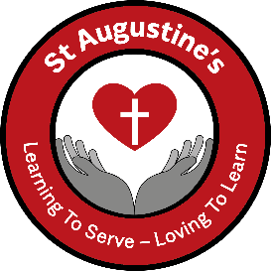

School Uniform

Available from the Just Schoolwear Website

|  |  |
| --- | --- |
|  |  |

**Girls uniform**: Grey skirt, trousers or pinafore, white shirt, red sweatshirt or cardigan and black shoes.  
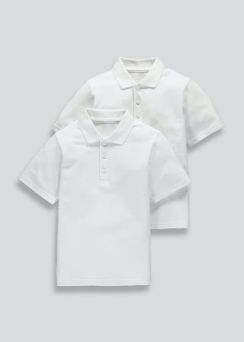 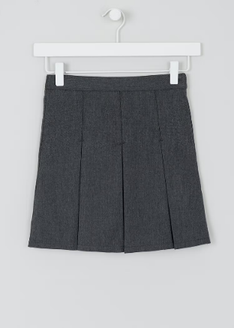 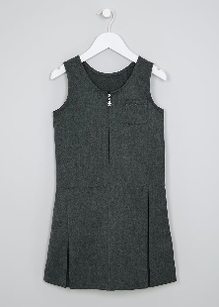 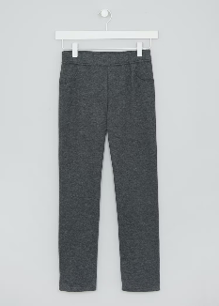 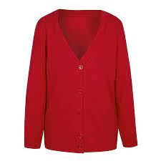 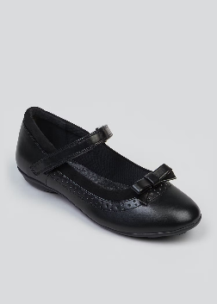

**Boys uniform**: Grey trousers, white shirt, red sweatshirt and black shoes.  
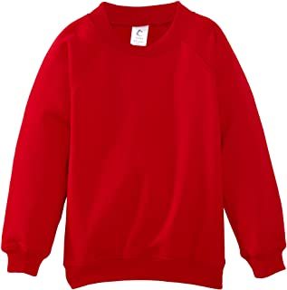 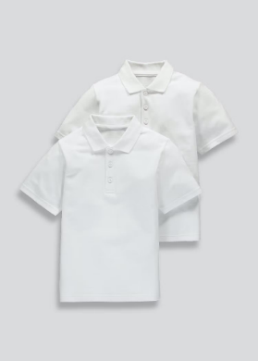 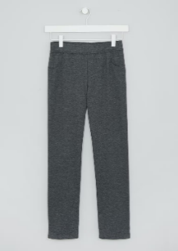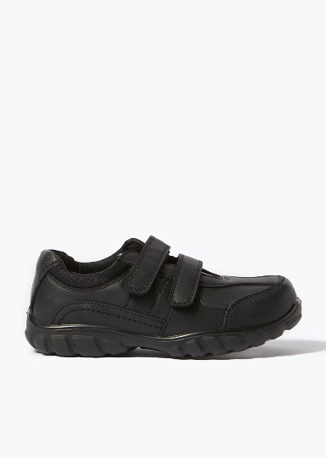

**P.E. kit**: White T-shirt, red shorts and trainers or plimsolls.  
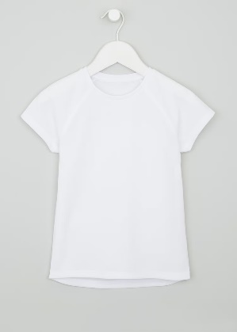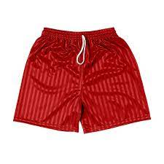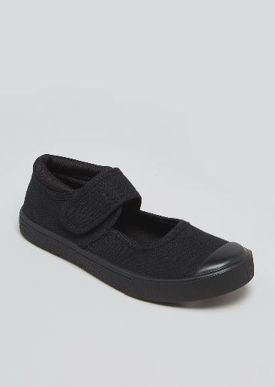

**Please order online at:**

[**https://just-schoolwear.co.uk/product-category/st-augustines-catholic-primary-school/**](https://just-schoolwear.co.uk/product-category/st-augustines-catholic-primary-school/)