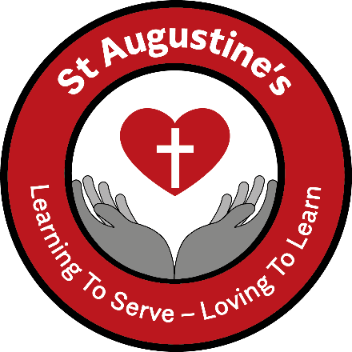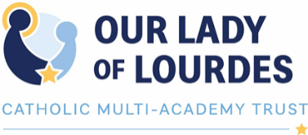

**Pupil Privacy Notice**

**Why are we giving this to you?**

As your school we need to use information about you. We do this for a number of reasons. This form tells you what information we use about you and why we use it. It is very important that information about you is kept safe. We explain below how the school keeps your information safe.

If you want to know anything about what we do with information about you then please ask your teacher, or speak to your parents/carers and ask them to contact the school. The school wants you to feel free to raise any questions at all.

There is also a person called the GDPR Lead at the school and a Data Protection Officer (DPO) at the Trust. They can answer any questions you have about what the school does with your information. If you or your parents/carers want to speak to them, they can be contacted at:

DPO Karen Rich [dpo@ololcatholicmat.co.uk](mailto:dpo@ololcatholicmat.co.uk)

**Policy Statement**

We are St Augustine’s Catholic Primary & Nursery Catholic School, part of the Our Lady of Lourdes Catholic Multi-Academy Trust. During your time with us, we will use information that we gather in relation to you for various purposes. Information that we hold in relation to you is known as “personal data”. This will include data that we obtain from you directly and data about you which we obtain from other people and organisations. We might also need to continue to hold your personal data for a period of time after you have left the school. Anything that we do with your personal data is known as “processing”.

This document sets out what personal data we will hold about you, why we process that data, who we share this information with, and your rights in relation to your personal data processed by us.

**What information do we use about you?**

We will collect, hold, share and otherwise use information about you set out in the boxes below:

|  |  |  |
| --- | --- | --- |
| * Name | * Telephone and email contact details | * Date of Birth |
| * Address | * Assessment information | * Details of previous/future schools |
| * Unique pupil number/ Unique learner number | * Behavioural information | * Language(s) |
| * Nationality | * Country of birth | * Eligibility for free school meals |
| * Photographs* | * Attendance information | * CCTV images |
| * Services Children   (if applicable) | * Post-16 Information such as UCAS references and Bursary details (if applicable) |  |

*\*****Photographs*** *– Schools may take individual photographs of you to be used on their Management Information System and registers for safeguarding purposes. These photographs will be taken by external photographers and may be made available to you/parents/carers to purchase. Photographs may also be taken of class/year groups and of normal school activities which may be used for internal displays within the school.*

We will also collect, hold, share and otherwise use some information about you which is special “special category personal data” and we will take extra care to make sure that this is kept safe:

|  |  |  |
| --- | --- | --- |
| * Racial or ethnic origin | * Religious beliefs | * Special educational needs and disability information |
| * Medical / Health information / Dietary requirements | * Biometric data | * Information relating to keeping you safe |
| * Gender |  |  |

**Where do we get this information from?**

We get this information from:

* You
* Your parents/carers
* Teachers and other staff
* People from other organisations, such as doctors or the local authority for example

**Why do we use this information?**

We use this information for lots of reasons, including:

* To make sure that we give you a good education and to support you through this
* To make sure that we are able to address and support any educational, health or social needs you may have
* To make sure everyone is treated fairly and equally
* To keep you and everyone at the school safe and secure (providing appropriate pastoral care, including support with the safeguarding agenda)
* To deal with emergencies involving you
* To celebrate your achievements
* To comply with the law regarding data sharing
* To monitor and report on your progress and provide additional information to your parents/carers
* To facilitate school transport and trips

Some of these things we have to do by law. Other things we do because we need to so that we can run the school.

Sometimes we need permission to use your information. This includes taking pictures or videos of you to be used on our website or in the newspaper etc. Before we do these things we will ask you or if necessary your parent/carer for permission.

**Why do we use special category personal data?**

We may need to use the information about you which is special (mentioned above) where there is a specific interest to do so for example health and social care purposes or to provide you with equal opportunities and treatment. We will also use this information where you have given us permission to do so.

There may also be circumstances where we need to use your information in relation to legal claims, or to protect your vital interests and where you are unable to provide your consent.

**How long will we hold information in relation to our pupils?**

We will hold information relating to you only for as long as necessary. How long we need to hold on to any information will depend on the type of information. Where you change school we will usually pass your information to your new school. For further details, please see our Retention & Destruction Policy.

**Who will we share pupil information with?**

We may share information about you with:

* Other schools or educational institutions you may attend or require support from Local Authorities, to assist them in the exercise of their responsibilities in relation to education and training, youth support and safeguarding purposes *(Children’s Act/Education Act/Education Regulations)*
* The Department for Education and/ or Education Skills Funding Agency as required by the law *(We share pupils’ data with the Department for Education (DfE) on a statutory basis. This data sharing underpins school funding and educational attainment policy and monitoring. We are required to share information about our pupils with the DfE under regulation 5 of The Education (Information about Individual Pupils) (England) Regulations 2013).*

*To find out more about the data collection requirements placed on us by the Department for Education (for example; via the school census), go to* [*https://www.gov.uk/education/datacollection-and-censuses-for-schools*](https://www.gov.uk/education/datacollection-and-censuses-for-schools)

*To find out more about the National Pupil Database (NPD), go to* [*https://www.gov.uk/government/publications/nationalpupil-database-user-guide-and-supporting-information*](https://www.gov.uk/government/publications/nationalpupil-database-user-guide-and-supporting-information)

* Contractors, to enable them to provide an effective service to the school, such as school meal providers or external tutors
* Assessment bodies, for example Examination Boards and Testing Agencies
* Public Health Bodies when mandated to do so

**Keeping this information safe**

It is very important that only people who need to use your information can see it. The school keeps your information safe by:

* Ensuring that only authorised people have access to it
* It is transmitted in a safe and secure manner
* Ensuring we have internal policies and controls in place to ensure that personal data is not lost, accidentally destroyed, misused or disclosed, and is not accessed by anybody without the required permissions

**Your rights in relation to your information**

You can ask to see the information we hold about you. If you wish to do this, you should contact:

DPO Karen Rich [dpo@ololcatholicmat.co.uk](mailto:dpo@ololcatholicmat.co.uk)

You also have the right to:

* Object to what we are doing with your information
* Have inaccurate or incomplete information about you amended
* Ask us to stop doing certain things with your information in some cases
* Ask that decisions about you are not made using automatic systems
* Claim against the school in certain circumstances where you have suffered as a result of the school breaching your data protection rights

If you feel it necessary to do any of the above, you can contact:

DPO Karen Rich [dpo@ololcatholicmat.co.uk](mailto:dpo@ololcatholicmat.co.uk)

The Academy/School/Trust does not have to meet all of your requests and we will let you know where we are unable to do so.

**Concerns**

If you are concerned about how we are using your personal data, then you can contact:

DPO Karen Rich [dpo@ololcatholicmat.co.uk](mailto:dpo@ololcatholicmat.co.uk)

Or, if necessary, you/your parents/carers can contact an outside agency - the Information Commissioner’s Office who could also help at <https://ico.org.uk/concerns/>.

Sept 2021